Brightspace Pulse
Learner Guide

Contents
Document Change History 3
Manage your course workload with Brightspace Pulse 4
Brightspace Pulse platform requirements 4
Log in and out of Brightspace Pulse 5
Navigate in Brightspace Pulse 6
View and edit activities in Brightspace Pulse 10
Add activities in Brightspace Pulse 12
Mark an activity as complete in Brightspace Pulse 12
View courses and course content in Brightspace Pulse 12
View notifications in Brightspace Pulse 14
Read and reply to discussion threads in Brightspace Pulse 15
Troubleshooting Brightspace Pulse 16
About D2L 18

Document Change History
This version of the document replaces all previous versions. The following table describes the most recent changes to this document.
Revision Date | Summary of Changes
February 6, 2020 | Updated the Navigate in Brightspace Pulse topic to update the iOS and Android interfaces.
January 2, 2020 | Updated the Brightspace Pulse platform requirements topic to update language support.  Updated the Change personal settings in Brightspace Learning Environment topic to specify 4000 character limit for Personal Info fields.
October 3, 2019 | Updated the Brightspace Pulse platform requirements topic to update iOS support.
September 5, 2019 | Updated the View notifications in Brightspace Pulse topic to add Activity Feed notification support.
July 4, 2019 | Updated the View notifications in Brightspace Pulse topic to reflect updated information about update notifications.  Streamlined several topics by consolidating information.
January 3, 2019 | Added the Enhanced course tiles topic to reflect new details that may display on course tiles in Brightspace Pulse.
October 4, 2018 | Updates to reflect language term changes in Assignments have been added to this guide.
August 2, 2018 | Updated the Courses and course content in Brightspace Pulse and View courses and course content topics to reflect updated navigation in the Courses tab.

Manage your course workload with Brightspace Pulse
Brightspace Pulse is a mobile app that can help learners stay connected and on track with their courses in Brightspace Learning Environment. It provides one easy view of course calendars, readings, assignments, evaluations, grades, and announcements. The app can help learners make better decisions about how to handle workload, when to submit assignments, and when to prepare for tests. Real-time alerts can let learners know when classes are canceled, rooms are moved, or new/updated course content and grades are made available. The schedule view and weekly visualization provides learners with a quick, at-a-glance view of what is due today, this week, and later in the term across all their courses.
Use Brightspace Pulse to:
- See all the important dates and deadlines for each course
- Mark activities as complete
- Anticipate busiest times with a quick glance
- Receive the latest grades, course content, and announcements
- Share updates by email, text message, and social media
- Enter events and deadlines
- View courses and course content
- View course details and customize how much assignments and tests are worth
- Seamlessly log in to Brightspace Learning Environment via a browser to complete tasks

Brightspace Pulse platform requirements
Brightspace Pulse is available for download from any global Google Play™ store or Apple App Store®. The app is generally released at the beginning of the month, and then sometimes mid-month, if issues are found. Depending on how your device is configured, the app may update automatically or you may have to manually check for new versions.
Brightspace platform support
Brightspace Pulse is compatible with Brightspace platform 10.5.1 and higher. By default, Brightspace Pulse is turned on for use in your organization.
Region and language support
Brightspace Pulse is supported in the following geographic regions:
- U.S.
- Canada
- Europe, Middle East, Africa (EMEA)
- Asia Pacific (Singapore and Australia)
You can download Brightspace Pulse in the following languages:
- Arabic (Saudi Arabia)
- Chinese (Simplified)
- Chinese (Traditional)
- Danish
- Dutch
- English (U.S.)
- French (Canada)
- French (France)
- German (Germany)
- Japanese
- Korean
- Portuguese (Brazil)
- Spanish (Latin America)
- Swedish
- Turkish
Operating system support
Brightspace Pulse is optimized for mobile devices with the following operating systems:
- AndroidTM 5.0 or later on tablets or phones
- iOS® 11.0 or later on iPhone®, iPad®, and iPod® touch

Log in and out of Brightspace Pulse
When you initially log in to Brightspace Pulse, you can quickly find your organization by turning on your device's geolocation service. Brightspace Pulse searches for all organizations within a 55km / 34-mile radius from your current location; however, the list may not include all institutions that use the Brightspace platform. If there are no search results, type the URL for your organization's Learning Management System (LMS).
After logging in, Brightspace Pulse loads your course data by retrieving calendar events from Calendar. These events might include dates from Content, Checklist, Discussions, Assignments, and Quizzes in Brightspace Learning Environment, if instructors set due dates in these tools.
To log in to Brightspace Pulse
- Tap the Brightspace Pulse icon.
- Learn more about Brightspace Pulse by swiping left/right or proceed to the next step by tapping Next.
- Tap Pick Your School.
- Enter your Brightspace Learning Environment credentials and then tap Log In.
To log out of Brightspace Pulse
- Tap the Settings icon:
  - (iOS)
  - (Android)
- Tap Sign Out.

Navigate in Brightspace Pulse
Brightspace Pulse features an intuitive interface for iOS and Android.
Brightspace Pulse interface overview (iOS)
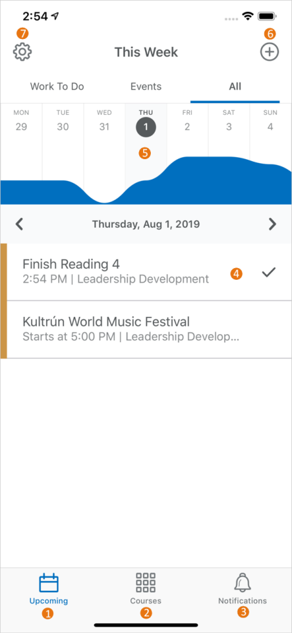
- The Upcoming tab displays upcoming work (activities) for your courses. You can filter the list of activities by tapping the Work To Do, Events, or All sub-tabs.
- The Courses tab displays the courses you are currently enrolled in, and a button to access the org homepage in Brightspace Learning Environment. By default, this tab displays when you log in to Brightspace Pulse.
- The Notifications tab displays notifications about course-related news, updates, and grades from Announcements, Grades, and Content in Brightspace Learning Environment. In addition, you can read and reply to discussion threads from this tab.
- The activity list displays a summary of your activities, for example, readings, assignments, and evaluations.
  - Navigate activities by swiping up or down.
  - Swiping left/right moves to the next/previous week. As you navigate, the graph updates.
  - Tapping an activity displays detailed information and actions you can perform.
  - Tapping a checkmark icon marks the activity as complete ().
- From the Upcoming tab, the graph displays upcoming activities at-a-glance, indicating which days are the busiest.
  - Navigate weeks by swiping left/right or using Apple VoiceOver. As you navigate, the activity list updates.
  - Tapping a day updates the activity list.
- The Add activity icon allows you to create activities to fill in any gaps in your schedule.
- The Settings icon allows you to log out, provide feedback, change graph settings, or view the version number.
Brightspace Pulse interface overview (Android)
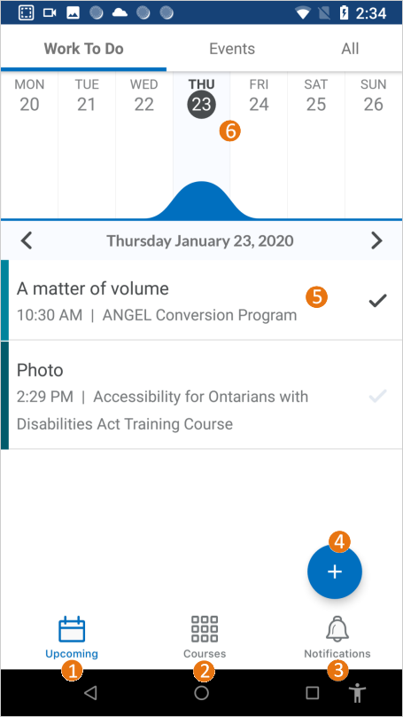
- The Upcoming tab displays upcoming work (activities) for your courses. You can filter the list of activities by tapping the Work To Do, Events, or All sub-tabs.
- The Courses tab displays the courses you are currently enrolled in, and a button to access the org homepage in Brightspace Learning Environment. By default, this tab displays when you log in to Brightspace Pulse.
- The Notifications tab displays notifications about course-related news, updates, and grades from Announcements, Grades, and Content in Brightspace Learning Environment. In addition, you can read and reply to discussion threads from this tab.
- The Add activity icon allows you to create activities to fill in any gaps in your schedule.
- The activity list displays a summary of your activities, for example, readings, assignments, and evaluations.
  - Navigate activities by swiping up/down.
  - Swiping left/right moves to the next/previous day. As you navigate, the graph updates.
  - Tapping an activity displays detailed information and actions you can perform.
  - Tapping a checkmark icon marks the activity as complete ().
- From the Upcoming tab, the graph displays upcoming activities at-a-glance, indicating which days are the busiest.
  - Navigate weeks by swiping left/right. As you navigate, the activity list updates.
  - Tapping a day updates the activity list for that day.
  - Streamline your view by tilting your device to landscape view, hiding the activity list.
- The Settings icon allows you to log out, provide feedback, change graph settings, or view the version number.

View and edit activities in Brightspace Pulse
Brightspace Pulse displays activities mapped from corresponding data in Brightspace Learning Environment and activities you create in Brightspace Pulse. These activities can include assignments (mapped from an assignment, discussion forum/topic, checklist, or survey), evaluations (mapped from a quiz or grade item), readings (mapped from a content topic), and personal checklist items.
To view and edit an activity
Tap an activity to display more details:
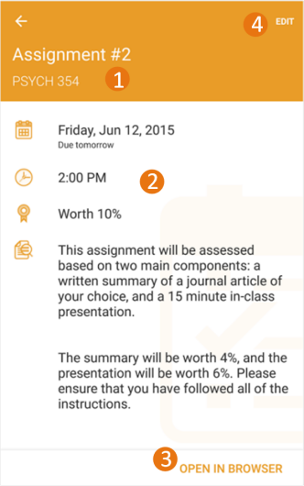
- Activity Title and Course.
Tip: To distinguish between personal activities you created in Brightspace Pulse and activities created by your instructors in Brightspace Learning Environment, a personal activity is identified by a Personal label.
- Activity details, for example, Date due, Time, Grade worth (this value is initially empty and must be set by the learner), and activity notes, for example, special instructions for an assignment.
- Tap Open in Safari (iOS) or Open in Browser (Android) to open the activity in Brightspace Learning Environment, for example, an exam in the Quizzes tool.
- Tap Edit to edit the activity details.
Note: When editing an activity created in Brightspace Learning Environment, the Title and Grade worth fields are the only editable fields.

Add activities in Brightspace Pulse
You can fill in any gaps in your schedule or add your own personal activities in Brightspace Pulse, for example, readings, study groups, or assignments.
Note: If you log out or delete the app, all personal dates are erased.
- Tap the Add activity icon: (iOS) or (Android).
- Tap an activity type: New Work To Do or New Event.
- Fill out the necessary fields. For example, for a New Work To Do activity, fill out the Title, Course, Date, and Percentage Worth.
Note: You must associate the activity with a relevant course in Brightspace Learning Environment.
- Tap Save.
- Tap OK.

Mark an activity as complete in Brightspace Pulse
After completing an activity, such as an assignment or reading, you can mark the activity as complete. The activity summary displays how many activities have been completed in the current week.
From the activity list, mark an activity as complete by tapping a check mark.
Tapping a check mark marks the activity as incomplete.

View courses and course content in Brightspace Pulse
From Courses tab in Brightspace Pulse, you can view the courses you are currently enrolled in and access your org homepage in Brightspace Learning Environment. By default, this tab displays when you log in to Brightspace Pulse. From there, you can select a course, where you can access course content and view the course homepage in Brightspace Learning Environment.
Supported content types
When viewing course content in Brightspace Pulse, supported content types include:
- HTML
- PDF (special features such as password protection are unsupported)
- MP4 video (H.264, AAC)
- DOC, DOCX
- XLS, XLSX
- PPT, PPTX
- MP3 audio
- Brightspace Capture video
Unsupported functionality includes:
- creating or editing course content hierarchy
- pinning and unpinning courses (all enrolled courses display in Brightspace Pulse)
Enhanced course tiles
If configured by your administrator, you can view details of your assigned courses on the course tiles that appear in Brightspace Pulse including:
- Course Due Date
- The date the course was completed by the user
- A Complete status indicator when all items in the course are complete
- An Overdue status indicator when items in the course are not complete by the due date
- Course update indicators with links to Assignments, Discussions, and Quizzes
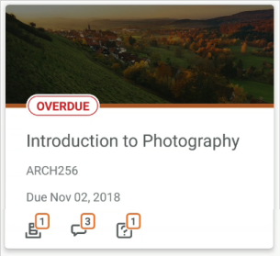
Figure: Details of a learner's assigned course on an enhanced course tile
To display these details, courses must be assigned using Learning Groups, have a due date, and have Course Completion Tracking enabled. Course update indicators do not require courses assigned using Learning Groups.
To view courses and course content in Brightspace Pulse
- Tap the Courses tab. This displays the courses you are currently enrolled in, and a button to access the org homepage in Brightspace Learning Environment.
- Tap a course. The course’s content displays, and a button to access the course homepage in Brightspace Learning Environment.
- From the table of contents, tap a module.
- Tap a topic to view it.
To view PDF and MP4 topic files offline
To complete learning activities without an Internet connection, learners can download PDF and MP4 topic files for offline viewing in Brightspace Pulse.
Note the following:
- Downloaded PDF and MP4 topic files can only be viewed in Brightspace Pulse. Although downloaded files use the mobile device's file storage, they cannot be viewed in another app or transferred from the mobile device.
- The limit of downloadable files is determined by the available space on the mobile device.
- For PDF files, there is no support for special PDF features (password protection, printing restrictions, etc.), or support for other document types (DOCX, XLSX, PPTX, HTML, images, etc.).
- For MP4 files, there is no support for streaming video, or other video and audio formats (MP3 audio, etc.).
- In Brightspace Pulse, view a topic file containing a PDF or MP4.
- From the ellipsis (...) menu at the top of the page, tap Make available offline.
- Without an Internet connection, in Brightspace Pulse, navigate back to the table of contents and tap the downloaded topic file, indicated by the Downloaded File icon.
- To remove the topic file from the mobile device, from the ellipsis (...) menu at the top of the page, tap Remove from device.
Tip: To remove all downloaded content files from the mobile device, navigate to the top-level for the course, tap the ellipsis (...) menu, and tap Remove any offline content.

View notifications in Brightspace Pulse
To ensure that you receive up-to-date information, Brightspace Pulse sends push notifications for all new and updated notifications. This removes the need to manually check for notifications. These notifications offer you tips and keep you informed about course-related news, updates, due dates, and grades from Announcements, Grades, and Content in Brightspace Learning Environment.
After logging in for the first time, course notifications do not appear until new updates are created in Brightspace Learning Environment.
Note: You cannot configure the notifications you receive in Brightspace Pulse.
To view notifications, tap the Notifications tab. The Updates sub-tab displays the following notification types:
- Introductory updates - When you log in to Brightspace Pulse for the first time, introductory notifications appear. Each notification provides a tip on how Brightspace Pulse can keep you notified about the latest grades and Announcements for your courses.
- Created or updated course content - To keep you informed about course content, Brightspace Pulse sends notifications when course content is created or updated in Brightspace Learning Environment. You can view new and updated content associated with a notification, viewing the content directly in Brightspace Pulse. This also applies to content where a due date has been associated with the item. To view the content, tap the update and then tap Open. If there is no file URL available, tap Open in browser, which opens the content in Brightspace Learning Environment.
- Created or updated Course Overview documents - When an instructor adds or updates the Course Overview document in Brightspace Learning Environment, you receive notifications in Brightspace Pulse and the Brightspace Learning Environment minibar.
In Brightspace Learning Environment, you can optionally choose to receive instant notifications via email or text message when the Course Overview document is updated.
- Course announcements - When an instructor wants to communicate changes to course updates, information, and reminders via course announcements, you receive a course announcement in Brightspace Pulse.
- Activity Feed - To help keep you up to date on course activity, Brightspace Pulse displays Activity Feed notifications, if the Activity Feed widget is enabled in your enrolled courses. For example, Brightspace Pulse sends notifications about Activity Feed messages and links to course materials.
- New grades - When an instructor enters grades in a grade book, you receive grade notifications in Brightspace Pulse. View grades in Brightspace Pulse by tapping the update and then swiping left to reveal the grade.

Read and reply to discussion threads in Brightspace Pulse
From the Notifications tab, you can read and reply to discussion threads. This increases awareness of course activity and encourages engagement in learning activities with other learners.
Unlike other notifications in Brightspace Pulse, discussion notifications do not appear in the device's notification area and do not invoke an alarm or vibration.
In Brightspace Learning Environment, you must first subscribe to a topic or discussion thread for a course offering you are enrolled in. You cannot subscribe or unsubscribe to topics or threads in Brightspace Pulse.
When reading and replying to discussion posts:
- A link is provided for viewing the original post, with original formatting, in a web browser.
- Formatting is simplified for consistency - bold, italics, underline, strikethrough, subscript, superscript, and HTML lists are supported. However, font face, color, size, images, and other embedded objects are unsupported.
- Web links (URLs) can be followed.
- Unlike Brightspace Learning Environment, the learner can only reply to the original post, not a specific post in the discussion thread.
- There are no formatting options when replying.
To read and reply to discussion threads
- Tap the Notifications tab. A red dot on the Subscriptions sub-tab indicates new or updated discussion threads.
- Tap the Subscriptions sub-tab. A list of discussion threads displays. The list is sorted with the discussion threads that have the most recent activity at the top, and any discussion threads that have new activity since you last checked are highlighted to indicate an unread state.
- Tap the thread containing the activity. A list of posts displays.
- Reply to the thread.

Troubleshooting Brightspace Pulse
I cannot find my organization or school when I search
If your organization or school does not display in the list when you search, you can add it manually using its URL. This field is available when there are zero search results or if you choose to disable your mobile device's geolocation service.
I cannot connect Brightspace Pulse to my school or organization
If you cannot connect to your school or organization, the problem could be:
- Your school or organization has turned off access. You can contact them to find out.
- You entered your ID or password incorrectly. Try again.
- Your school or organization is using a Brightspace platform version that is incompatible with Brightspace Pulse.
I cannot see the courses that I am enrolled in
It's possible that the courses you're enrolled in haven't started yet or they don't have any dates associated with them.
I don't see any updates in the Updates tab or I cannot access my course documents, announcements, grades, etc.
When you initially log in to Brightspace Pulse, no course content updates appear until new updates come from Brightspace Learning Environment; however, introductory updates appear. The Brightspace Pulse app provides you with updates when announcements are created in your courses and when you receive new grades from your instructors.
Percentage values don't appear for any of my activities
While Brightspace Pulse can retrieve data from your courses in Brightspace Learning Environment, it cannot determine percentage values for individual activities. Percentage values must be manually added by learners in Brightspace Pulse.
I don't see updated course content in the Updates tab
Course content updates only appear in the Updates tab if the instructor checks the Notify students that the content has changed option for the updated content in Brightspace Learning Environment. Contact your instructor for more information.

About D2L
A global leader in EdTech, D2L is the creator of Brightspace, the world’s first integrated learning platform.
The company partners with thought-leading organizations to improve learning through data-driven technology that helps deliver a personalized experience to every learner, regardless of geography or ability. D2L’s open and extensible platform is used by more than 1,100 clients and almost 15 million individual learners in higher education, K–12, healthcare, government, and the enterprise sector—including Fortune 1000 companies.
The company has operations in the United States, Canada, Europe, Australia, Brazil, and Singapore. www.D2L.com

Contact Us
Phone: | 1.519.772.0325 (Worldwide)
Toll Free: | 1.888.772.0325 (North America)  0.808.234.4235 (United Kingdom and Europe)  0.800.452.069 (New Zealand)  1.800.656.210 (Australia)  0.800.891.4507 (Brazil)
Fax: | 1.519.772.0324
Email: | info@brightspace.com
Twitter: | @Brightspace
Web: | www.D2L.com

© 2020 D2L Corporation.
The D2L family of companies includes D2L Corporation, D2L Ltd, D2L Australia Pty Ltd, D2L Europe Ltd, D2L Asia Pte Ltd, and D2L Brasil Soluções de Tecnologia para Educação Ltda.
Brightspace, D2L, and other marks ("D2L marks") are trademarks of D2L Corporation, registered in the U.S. and other countries. Please visit d2l.com/trademarks for a list of other D2L marks.

