Brightspace Learning Environment
Learner Guide

Contents
Document Change History 5
Find your Brightspace username 8
Log in to Brightspace Learning Environment 9
Navigate Brightspace Learning Environment 10
Change personal settings in Brightspace Learning Environment 11
Log out of Brightspace Learning Environment 13
Search for courses and self-enroll using Discover 14
Navigate course content in the classic Content experience 16
Access course content using the ReadSpeaker docReader integration 17
Review completed SCORM objects in a course 17
Meeting accessibility standards in HTML authored content 18
Use the Accessibility Checker on HTML-authored content 18
Create and insert a video note in HTML Editor 18
Add closed captions to a video note 19
Create a video note attachment 20
Reuse video notes 20
Navigate course content in the new Content experience (Lessons) 21
Using Blackboard Ally to view alternative accessible formats of content 26
View live or recorded webcast presentations with Brightspace Capture 27
View an on-demand CaptureCast presentation 27
Search and navigate a CaptureCast presentation 27
Send a message to all CaptureCast participants in a live chat 27
Ask a general question in a live CaptureCast event chat 27
Private message a participant of a live CaptureCast event chat 28
Add comments and replies to an on-demand CaptureCast presentation 28
View course announcements with the Announcements tool 29
Subscribe to an Announcements RSS feed 29
Enable notifications in Announcements 29
Manage course events with the Calendar tool 30
Import a calendar from your computer into the Calendar tool 31
Change Calendar settings 31
Subscribe to a calendar 31
Take a quiz 32
Submit an assignment 33
Understanding due dates and end dates 33
View assignment feedback 34
View your grades 35
How do I know when my grades are available? 35
Where do I go to view feedback for quizzes, assignments, and discussions? 35
Viewing Grade Item Exemptions 35
How rubrics relate to your grade 36
View course achievements with Awards 38
About new award notifications 38
To view awards 38
Share earned awards 39
View course progress with the Class Progress tool 40
View course progress against learning outcomes 42
Reflect on your learning with the Self Assessments tool 44
Create an Activity Feed post 45
Find and contact other learners in your course with Classlist 47
Share information using the Blog tool 48
View your own blog 49
Write a blog entry 49
Edit blog entries 49
Find and follow other users' blogs 49
Publish your blog as an RSS feed 50
Add blog comments 50
Delete blog comments 50
Create a personal chat with the Chat tool 51
Change your chat settings 51
Manage chat history 52
Add or remove users from a chat 52
Create a discussion thread 53
View a discussion topic 53
Reply to a discussion thread 54
Change discussion settings 55
Subscribe to a discussion 55
Unsubscribe from a discussion 55
Email other learners with the Email tool 56
Where can I find my Instructor's email? 56
I am unable to login to my school email portal (not Brightspace), what do I do? 56
Why can I only see some emails in my inbox? 56
How can I forward my D2L emails to another account? 56
I get a "Not Authorized" error trying to access my Email, what do I do? 57
I cannot access my email inbox, I can only send emails 57
Upload, store, and share files with the Locker tool 58
Find other learner's shared locker files 58
Submit course feedback with the Surveys tool 59
Anonymous participation in a survey 59
Why can't I create a survey? 59
About D2L 60

Document Change History
This version of the document replaces all previous versions. The following table describes the most recent changes to this document.
Revision Date | Summary of Changes
February 6, 2020 | Updated the View assignment feedback topic to include new workflow for accessing inline feedback.  Updated the View course progress against learning outcomes topic to include information about learners ability to view quiz attempts.  Removed all Brightspace Wiggio topics.
January 2, 2020 | Updated the Change personal settings in Brightspace Learning Environment topic to specify 4000 character limit for Personal Info fields.
November 7, 2019 | Updated the Search for courses and self-enroll using Discover topic to include the option to self-unenroll from courses.  Updated the Create a video note attachment and Create and insert a video note in HTML editor topics.  Updated a note in the View course progress against learning outcomes topic to reflect that the lang term for Standards depends on a config setting.  Removed Participate in a poll during a live CaptureCast event.
September 5, 2019 | Updated the Create Activity Feed post topic with information about new attachment workflow and inline rendering of attachments.
August 1, 2019 | Updated the Change personal settings in Brightspace Learning Environment topic to reflect new and removed notification options.  Updated the View course progress with the Class Progress tool topic and added the View course progress against learning outcomes topic to reflect the new Standards tab for viewing progress on learning outcomes.  Updated the Navigate course content in the new Content experience (Lessons) topic to reflect user interface changes.
July 4, 2019 | Added the new Using Ally to view alternative accessible formats of content topic.  Updated the Change personal settings in Brightspace Learning Environment topic to include changes to the user-profile badge.  Updated the Navigate course content in the new Content experience (Lessons) topic to reflect user interface changes.
June 6, 2019 | Updated the Change your chat settings topic.  Added the Search for courses and self-enroll using Discover topic.
May 2, 2019 | Removed all legacy topics for Brightspace Binder.  Removed reference to Binder from Change personal settings in Brightspace Learning Environment.
April 4, 2019 | Added the Create Activity Feed post topic.
March 7, 2019 | Added the following topics: Access course content in the new Content experience (Lessons), Navigate the table of contents, and View course content.  Renamed the View course content topic to Access course content in the classic Content experience.
February 7, 2019 | Updated the Submit assignments topic to include a step on viewing Grammar feedback on submitting assignments.
November 1, 2018 | Added the Add closed captions to a video note topic, and updated the Create and insert a video note in HTML Editor topic.
October 4, 2018 | Updated the Content tool overview for learners topic to remove the Send to Binder functionality and update the screenshot to reflect the Daylight interface.  Updated the How rubrics relate to your grade topic to remove references to rubrics in Quizzes.  Updates to reflect language term changes in Assignments have been added to this guide.  Updated the following topics with rubrics updates in Assignments: How rubrics relate to your grade, Submit assignments, and View feedback in Assignments.  Added the Getting started section to include the following new topics: Find your Brightspace username, Log in to Brightspace Learning Environment, Navigating Brightspace Learning Environment, Change personal settings in Brightspace Learning Environment, and Log out of Brightspace Learning Environment.  Updated the Take a quiz topic.
September 6, 2018 | Updated the Submit assignments topic to include a note about viewing your Submission ID.  Updated Brightspace Wiggio topics to remove information on Virtual Meetings, as they are no longer available.  Updated the Where do I go to view feedback for quizzes, assignments, and discussions? topic to reference the Class Engagement tool.
August 2, 2018 | Added the Where do I go to view feedback for quizzes, assignments, and discussions topic, which formerly only appeared in the Brightspace Help. Added User Progress and Content to the locations a learner can view feedback.
July 5, 2018 | Updated the Submit assignments topic to include the note about submissions made to Turnitin enabled folders. This topic also includes new steps to include new Text Submission feature.  Updated the View feedback in Assignments topic to include information on viewing formative feedback in GradeMark.
June 7, 2018 | Updated the How rubrics relate to your grade topic to include interface changes for rubric feedback.

Find your Brightspace username
Your organization sends you an email containing your username for accessing Brightspace Learning Environment. The subject line of the email varies by organization, for example, <school name>: Enrollment Confirmation. If you did not receive an email with this information, contact your organization. For example, if you are a student, contact your Registrar's Office.
In addition to your username, the email contains a link to set up a password and a link to log in to Brightspace Learning Environment.
Tips:
- The email address you should check is the same email address that your organization account is associated with. For example, if you are a student, the email address usually has the school name or acronym after the “@” sign.
- The subject line of the email varies by organization. For example, the subject line might be: <school name>: Enrollment Confirmation.
- Passwords must be between 8 and 50 characters. For enhanced security, D2L recommends including lowercase and uppercase alphabetic characters, numbers, and symbols.
- To easily access Brightspace Learning Environment in the future, D2L recommends bookmarking the log in page in your favorite browser.

Log in to Brightspace Learning Environment
Note the following:
- If this is your first time accessing Brightspace Learning Environment, you may not be enrolled yet. For example, if you are a college student, wait until the start date of the semester to log in. If the start date has passed and you are still unable to log in, contact your Registrar’s Office to verify that you are enrolled and that you are using the correct login credentials.
- If you receive a message that your account has been locked, this means that you have unsuccessfully attempted to log in to Brightspace Learning Environment six times. Try logging in again in 15-30 minutes.
- From a supported browser, browse to the URL provided by your organization.
- Enter your Username and Password.
Tip: If you forget your password, click Forgot your password. Your organization sends you a password reset link to the email address associated with the username you specify.
- Click Log In.

Navigate Brightspace Learning Environment
To navigate Brightspace Learning Environment
The following common interface elements help you navigate Brightspace Learning Environment:
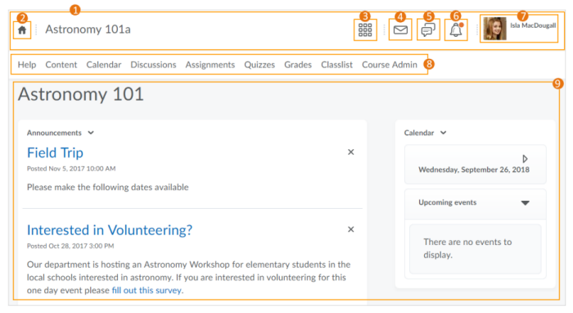
- Minibar - The minibar is always visible and helps you navigate Brightspace Learning Environment.
- My Home - Returns you to your organization's homepage. You can usually find important information from your organization on the homepage.
- Course Selector - Use the course selector to access your courses. For easy access, you can pin your courses to the top of the list.
- Messages - Notifies you about unread mail and instant messages from instructors and other learners.
- Updates - Notifies you about new and updated announcements, due dates and end dates, and grades.
- Subscriptions - Notifies you about new blog posts, subscribed discussion forums, topics, and threads.
- Username - Allows you to make changes to your user profile, notifications, account settings, and log out.
- Navbar - Provides links to course-specific tools, for example, Discussions, Assignments, and Quizzes. The navbar may change depending on your course.
- Course Homepage - Provides quick access to important information related to the course, for example, announcements and calendar items. The course homepage for each course may be different.

Change personal settings in Brightspace Learning Environment
From your username on the minibar, you can make changes to your user profile, notifications, account settings, and log out.
To change personal settings in Brightspace Learning Environment
- On the minibar, click your username.
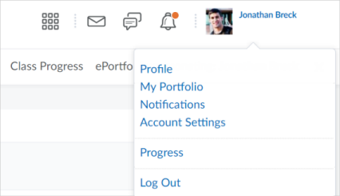
- Click a setting:
Note: Depending on your permissions and what tools are enabled, additional settings may appear.
  - Profile - set your profile picture, contact information, social networks, education information, work information, and personal information.
Note the following:
    - All long text fields under Personal Info are limited to 4000 characters each.
    - If you do not upload a user profile image, the navbar displays your initials in the user-profile badge. This displays in the Brightspace Learning Environment navbar and Activity Feed.
  - Notifications - control how you receive notifications about activity in your courses. You can receive a periodic summary of activity, or receive individual notifications as things happen. Specifically, you can:
    - download Brightspace Pulse to help you stay connected and on track with your courses
    - set your contact methods (email address and mobile number)
    - set how often you want to receive an email summary of activity for each of your courses
    - set individual notifications for activity in specific tools
Note: To receive content-related individual notifications, D2L recommends using the Brightspace Pulse mobile app or select the Email option for the individual notification type.
    - set custom notifications for grade values, and current and future courses
    - exclude specific courses from notifications
  - Account Settings - change settings for fonts; dialogs; HTML Editor; reading content; video; locale and languages; time zone; pseudo-localization; signing in; applications; discussions; email; and metadata.
  - Log Out - log out of Brightspace Learning Environment.

Log out of Brightspace Learning Environment
- On the minibar, click your username.
- Click Log Out.

Search for courses and self-enroll using Discover
To provide you with greater flexibility and control over your personal learning goals, the Discover tool allows you to search for active courses and self-enroll. You can also self-unenroll from the courses you self-enrolled in.
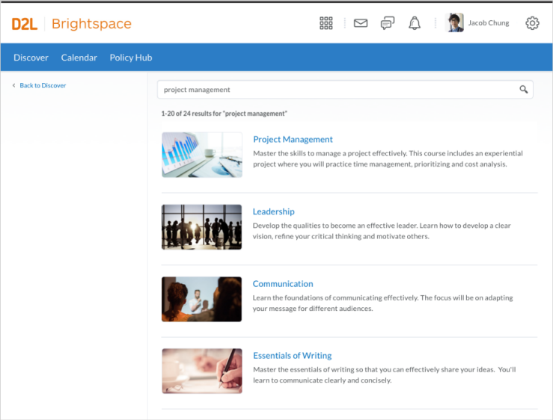
Figure: Search results for courses in Discover
Note the following:
- Only courses that allow self-enrollment (configured by course administrators or instructors) appear in the search results.
- You can enroll in a course prior to its Start Date (if configured), but you cannot enroll in a course past its End Date (if configured).
- Discover uses fuzzy search to match the course title and description. For example, typing "chemistry" may return search results for "biochemistry" and "chemistry".
To self-enroll in a course
- From the navbar, click Discover.
- Search for active courses by entering terms that match course titles and descriptions.
- From the search results, select the course you want to enroll in.
- From the course details page, click Enroll in Course.
To self-unenroll from a course
- From the navbar, click Discover.
- Search for the enrolled course you want to self-unenroll from.
- From the (...) Options menu on the course details page, click Unenroll.
Note: The Unenroll option appears only if you assigned yourself to the course.

Navigate course content in the classic Content experience
In the classic Content experience, use the Content tool to access course materials, complete required activities, and monitor your completion progress on topics contained within each course module.
An overview of the Content tool
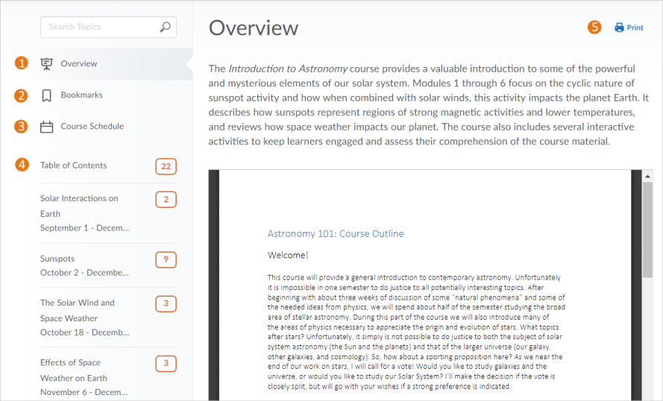
- When you access a course's Content tool for the first time, the first page you land on is the Overview, which instructors might use to post the course syllabus and introductory material. You can print and download a course syllabus directly from the Overview page. If your instructor has left the Overview blank you will not see it listed and you will land on the Table of Contents.
- Topics you bookmark appear in a list on the Bookmarks page. The number beside the Bookmarks link indicates how many bookmarks you have.
- The Course Schedule page lists course material due dates, start dates, end dates, overdue course activities, and all events within the course from the Calendar tool for the next seven days. The number of overdue items in the course appears in red. Course events are also listed in the Calendar tool. Only topics with a set due date but no end date or an end date later than the due date appear on this list since you must have time remaining after the due date to access and complete the topic. The Overdue tab only appears if you have content topics that are not complete by the set deadline. The number of overdue topics in the Overdue tab appears in red beside Course Schedule in the Content menu. When you access an overdue topic, it disappears from the list in the Overdue tab. When you complete all overdue topics, the Overdue tab disappears from the Course Schedule area.
Note: Adding a due date to a content item that is associated to an assignment will override an end date that is also set on the same assignment.
- The Table of Contents panel lists all modules available in your course. If numbers appear beside each module name in the Table of Contents panel it indicates that topics are being tracked for completion, and that you have a number of topics you have not accessed.
- Print your course outline, or navigate to a module's landing page to print a module's outline.

Access course content using the ReadSpeaker docReader integration
The ReadSpeaker docReader integration provides audio rendering of supported document types in the Content tool. If your organization has enabled this feature, you can hear audio playback of the following document types:
- ePub (.epub)
- Microsoft Excel (.xls, .xlsx)
- Microsoft PowerPoint (.pps, .ppt, .pptx)
- Microsoft Word (.doc, .docx)
- OpenOffice/OpenDocument Presentation (.odp)
- OpenOffice/OpenDocument Spreadsheet (.ods)
- OpenOffice/OpenDocument Text (.odt)
- Portable Document Format (.pdf)
- Rich Text Format (.rtf)
When you select ReadSpeaker docReader, a new content viewer appears with volume and playback controls.
Within a Content topic, on the Content viewer page, click Open with docReader in the topic context menu or on the page.

Review completed SCORM objects in a course
When learners have completed a SCORM object in their course, they can go back to review the content. When they open the object for the second or subsequent time, learners are prompted whether they want to retake the content (which removes their existing score or completion flag), or just review the content (which does not remove the existing score or completion flag).

Meeting accessibility standards in HTML authored content
Learners can use an accessibility checker in the HTML editor to ensure that the content they add to Brightspace Learning Environment meets accessibility standards for their peers and instructors.
The accessibility checker is available on the HTML Editor bar. After you add content to the HTML Editor, you can click the checker to ensure that the HTML page meets conformance to WCAG and Section 508 accessibility standards.
The accessibility checker reviews content for use of the following items:
- Use of paragraphs as headings
- Sequential headings
- Adjacent links
- Ordered list structure
- Unordered list structure
- Contact ratio of text to background colors
- Image ALT text
- ALT text filename
- Table caption
- Complex table summary
- Table caption and summary
- Table heading scope, markup, and headers
The checker indicates if there are no identified accessibility issues, or offers suggestions to fix any found issues.

Use the Accessibility Checker on HTML-authored content
The accessibility checker gives you a way to ensure that the content you author in the HTML Editor conforms to WCAG and Section 508 accessibility standards. The accessibility checker is available within the HTML Editor for use within Content, Widgets, Quizzes, Assignments, Calendar, Assignments, Discussions and any other tools where a user can access the HTML Editor.
- Enter HTML content in the HTML Editor.
- Click to start the checker.
- If there are any compliance issues, read the report for suggestions on how to fix the issue.

Create and insert a video note in HTML Editor
- In the HTML Editor, click Insert Stuff.
- Click Video Note.
- Select Upload File or Choose Existing.
If you select Upload File, do the following:
- Click Choose File and select the locally saved file you want to upload.
Note: You can only upload MP4, FLV, F4V, or MOV files that are less than 5.00 MB in size.
- Click Next, and enter a title and description.
- Click Next, and then Insert.
If you select Choose Existing, do the following:
- Select Video Note Search.
- Select your desired pre-existing Video Note
- Click Add.

Add closed captions to a video note
- Create a video note in the HTML Editor using Insert Stuff.
- Using a text editing program such as Notepad (PC), or TextEdit (Mac) create a .vtt file with the following format:
WEBVTT [Required on first line to indicate file type]
00:01.000 --> 00:03.000 [start and end timestamp in minutes:seconds.milliseconds]
Insert caption text here [Type the captions you want displayed during this portion of the video]
00:04.000 --> 00:08.000
Insert caption text here.
00:09:000 --> 00:14.000
Insert caption text here.
- Save the text file as a .vtt file by including .vtt at the end of the file name, and setting the file type to All files.
- Return to Brightspace Learning Environment.
- From Admin Tools, select Video Note Captions.
- Search for the video note created in the previous steps and click it.
- Click Choose File, locate the .vtt file created in the previous steps, and click Open.
- Click Save Captions.
- Click the Video Preview, and select the options menu (...).
- Click Captions to change from Captions Off to Captions Default.
- Play the video and confirm the closed captions are visible and display at the appropriate times.
Note: For more info on creating .vtt files, visit How to Create A WebVTT File. Ensure you follow the formatting exactly or the captions won't display. Any compatible 3rd party captioning method can also be used to complete this process.

Create a video note attachment
In some tools: Email, Intelligent Agents, and Feedback, you can attach new or existing video notes. These are embedded in an html file and require the user to be logged into the platform to view.
- From the Attachments area of the tool you are in, click Record or Choose Existing. To Record a video note, select the Record dropdown and select Record Video.
- Select New Recording.
- When you are finished recording, select Stop Recording. To re-record the video, repeat Step 2 and Step 3.
- Select Add.
To choose an existing video:
- Select Choose Existing.
- Select Video Note Search
- Enter your search terms in the Search Notes field, then select Search. You can also perform a blank search to see all search results.
- Select the video you want to insert.
- Select Add.

Reuse video notes
If you have created previous video notes, and if you have permission to search and insert video notes, you can reuse video notes.
- In the HTML Editor click the Insert Stuff icon.
- Click Video Note Search.
- Enter your search terms in the Search Notes field, then click Search. You can also perform a blank search to see all search results.
- Select the video you want to insert and click Next.
- You can preview the video note before you insert it.
- Click Insert.

Navigate course content in the new Content experience (Lessons)
To offer a more streamlined and intuitive interface, the new Content experience (Lessons) for learners includes the following improvements:
- Enhanced table of contents
- Full screen viewer for content
- Completion tracking
- End of module experience
Note: The new Content experience for learners is an optional experience, enabled by your administrator or instructor. It may not be enabled for your organization or for specific courses you are enrolled in.
From the Course Selector, access a course with the new Content experience enabled, and then click Content.
To navigate the new Content experience (Lessons)
In the new Content experience for learners, the table of contents allows you to explore all available content within the course (modules, topics, activities). At any time, you can choose an available module to view; you aren't forced to view modules in a specific sequence.
The state of the table of contents persists from session to session, allowing you to easily resume from where you left off. For example, an open module in the table of contents remains open after logging in again.
When you initially access a course, a Get Started tile prompts you to start the first course module. When you finish viewing content and come back to the course later, a Continue tile displays, allowing you to quickly resume from where you last finished viewing content.
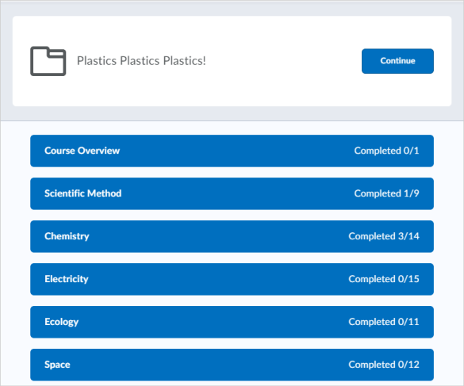
The table of contents also provides completion tracking information, which details your progress in course modules. This helps you see the completion status of topics in each module and easily identify which modules you haven't started.
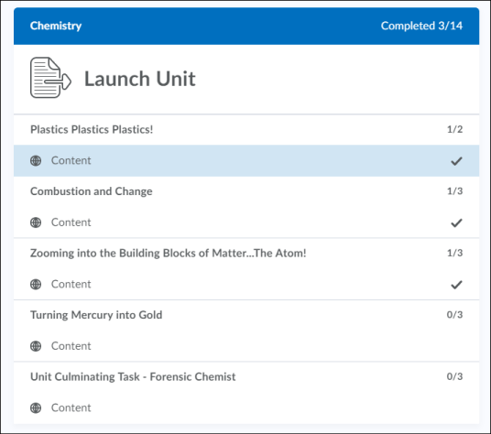
Completion tracking information is also visible from the navigation panel for modules and topics.
In the new Content experience for learners, when you decide what you want to view, click content from the table of contents. The item displays in a full screen viewer, allowing you to focus exclusively on the content, free from distractions in the interface.
Note: At this time, the new Content experience does not support downloading and printing content. As a workaround for printing content, use your browser's print functionality.
From the title bar, navigate sequentially through content by clicking the arrow buttons or choose specific content to view by clicking the collapsed menu icon. At any time, you can return to the table of contents by clicking Content.
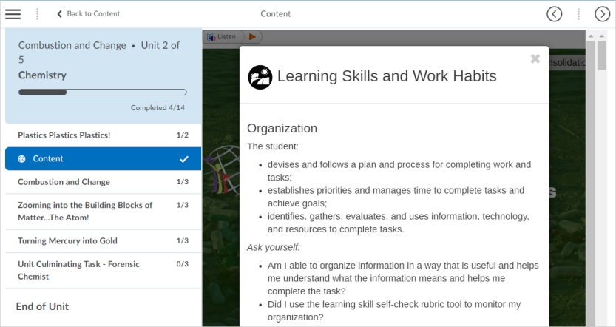
To provide you with more contextual course information in the new Content experience, a section in the table of contents menu displays the name of the course and overall course progress.
When you reach the end of a module, a dynamic page congratulates you on your achievement and displays completion tracking information for the module; a reminder about incomplete content may display. Clicking on content in the list takes you to that content. To return to the table of contents, click Back to Table of Contents.
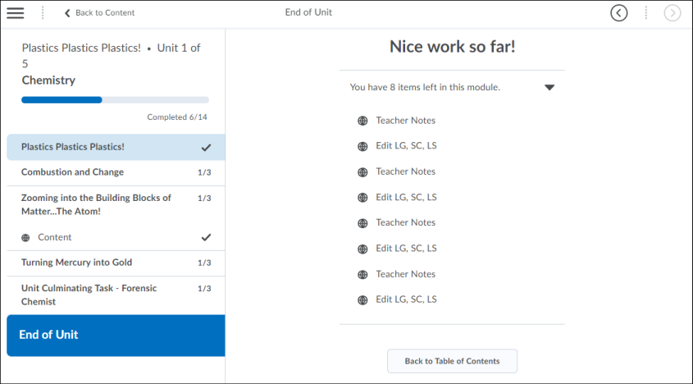

Using Blackboard Ally to view alternative accessible formats of content
Blackboard Ally is a content accessibility service licensed directly from Blackboard. It generates alternative accessible formats for files in the course content. In addition to the original format, Blackboard Ally provides the following alternative formats:
- Tagged PDF (for mobile)
- HTML
- ePUB
- Electronic Braille
- Audio
Note: If there is metadata or embedded security in a document, you are unable to create alternative accessible formats.
To view an alternative accessible format in a course module:
- Click to select a document from a course module.
- Click Alternative formats.
- Select an alternative format from the available list.
For more information, see Blackboard Ally Help.

View live or recorded webcast presentations with Brightspace Capture
Brightspace Capture enables you to view CaptureCast presentations as part of course content. If you are a user with access to Capture Portal, you can access live webcast presentations with your computer or mobile device, look for scheduled live events from the Capture Calendar page, interact with other attendees and presenters through chat, and view presentations on-demand after past live events and offline recordings are published. If you are a Brightspace Learning Environment user, you can view live events and on-demand CaptureCast presentations in your course content.

View an on-demand CaptureCast presentation
You can view live and on-demand CaptureCast presentations from the following locations:
- Brightspace Capture Portal
- Linked directly from the Capture widget on your course homepage
- Embedded as course content in Brightspace Learning Environment
- Embedded as LTI objects in alternative learning management systems
- Embedded elsewhere via the EMBED method

Search and navigate a CaptureCast presentation
- Hover over the timeline bar to see a thumbnail view of the chapters in the presentation.
- In the thumbnail bar, do any of the following:
  - Click on a thumbnail to navigate to a particular chapter and / or time in the presentation.
  - Enter a search query in the text box at the bottom of the menu to search within the presentation for specific chapters or sections of the transcript if available.

Send a message to all CaptureCast participants in a live chat
- In the live event Chat tab, type your message in the Send a regular message text box.
- Press Enter.

Ask a general question in a live CaptureCast event chat
General questions are reviewed and answered at the discretion of the presenter.
- In the Chat tab, type your message in the Ask a question text box.
- Press Enter.

Private message a participant of a live CaptureCast event chat
Messages entered in a private chat are only visible to the person that you are communicating with.
- In the chat attendance list, click a participant’s name.
- In the text box, type your message.
- Press Enter.

Add comments and replies to an on-demand CaptureCast presentation
You can create public and private comments for a presentation after it is published to the Brightspace Capture Portal. Public comments are visible to all users of the portal and cannot be edited once they are posted. Private comments are personal notes that only you can see. You can also link your comments to a particular time stamp in the presentation.
You can reply directly to your own and other viewers' public comments.
- In your Brightspace Capture Portal, on the Home page or Published Events page, click the presentation that you want to view.
- Do one of the following:
  - In the Post a comment field, type your comment.
  - If you want your comment or reply to reference a specific time in the presentation, pause the presentation at that point in time. In the Post a comment field, type your comment. Select the Link to the current play position check box.
Note: You can only link to one play position per comment.
  - If you want to make the comment private, select the Make this comment private check box.
Note: Once you post a public comment, you cannot edit it.
  - If you want to enter a reply to an existing comment, click Reply and enter your comment in the Post a comment text field.
- Click Post Comment.

View course announcements with the Announcements tool
Use the Announcements tool to read instructor messages, course information, and other Announcements updates.
Announcements items appear in the Announcements widget, but you can also receive instant notifications about postings through email, SMS, and RSS feeds.
Global Announcements items appear in the same My Home, Course Home pages, and Announcements widgets as course-related Announcements items.

Subscribe to an Announcements RSS feed
You can subscribe to an Announcements RSS feed and receive daily updates of all Announcements items in an RSS reader. This allows you to access an aggregate of Announcements items without logging into Brightspace Learning Environment.
- On the navbar, click Announcements.
- Do either of the following:
  - On the Announcements page, from the More Actions button, click RSS.
  - From the Announcements widget menu, click RSS.
- From the Subscribe to the feed using drop-down list, select an option.
- Click Subscribe Now.

Enable notifications in Announcements
You can sign up to receive immediate text or email notifications when new and updated Announcements items appear.
Before you begin: You must set up a contact method before subscribing to notifications.
- From your personal menu on the minibar, click Notifications.
- For the Announcements - item updated option and Announcements - new item available option, select if you want to receive email or SMS notifications.

Manage course events with the Calendar tool
Use the Calendar tool to arrange and visualize course events in multiple views and enable integration of course content and your Calendar. You can use iCal to synchronize the Calendar tool to your personal calendars (such as Outlook and Google Calendar, as well as iPhone and Android).
To navigate the Calendar tool
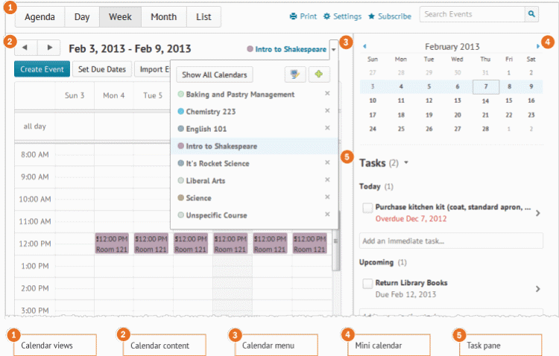
1) Use the calendar views area to toggle between different event display layouts. Use the Agenda view to group your course events by Date, Course, or Category - events display in chronological order, and all-day events display at the top of each grouped listing. Use the Day, Week, and Month views to group your events in daily, weekly, or monthly increments. Use the List view to filter your events by Assignments, Checklists, Discussions, Grades, Materials, Modules, Quizzes, and Surveys.
2) Use the calendar content area to navigate through your content. Navigation will vary depending on the view you select.
3) Use the calendar menu to select multiple calendars to display, change the color scheme associated with individual calendars, and add new calendars.
4) Use the mini calendar to navigate quickly to a specific day, week, or month.
5) Use the task pane to create, track, and maintain personal tasks.

Import a calendar from your computer into the Calendar tool
You can add new events and update existing events by importing them from an external iCal file into your Calendar.
- On the navbar, click Calendar.
- From the calendar menu, click the course you want your events to be grouped under.
- Click Import Events.
- To search for the iCal file containing your events, on the Import Events page, click Browse. If you want to import the events into a specific group or section, in the Attendees drop-down list, select the group or section.
- Click Open > Import.

Change Calendar settings
- On the navbar, click Calendar.
- Click Settings.
- Make your changes.
- Click Save.

Subscribe to a calendar
Use iCal feeds to access your Calendar events outside of the learning tool. With iCal feeds, you can view your course events in external calendars such as Microsoft Outlook and Google Calendar, and on mobile devices such as iPhones, BlackBerry smartphones, and Android phones.
Subscribing to an iCal feed syncs your external calendar application or device with the Calendar tool, keeping you updated without logging in to Brightspace Learning Environment. Refer to your device or application instructions for adding an iCal feed, as each application can have a different method for managing iCal feeds.
- On the navbar, click Calendar.
- In the Calendar views area, click Settings.
- Select the Enable Calendar Feeds check box.
- In the Calendar views area, click Subscribe.
- From the drop-down list, select which calendar you want to subscribe to, or select All Calendars and Tasks, or Tasks Only.

Take a quiz
Use the Quizzes tool to take a quiz, review your quiz results, and see class statistics for a quiz.
To take a quiz
- On the navbar, click Quizzes.
- On the Quiz List page, click on the quiz you want to take.
- Read the instructions and details for the quiz, and when you're ready, click Start Quiz!.
- Answer each question. As you complete the question, the answer will automatically save. You can see which questions have saved answers in the Questions section of the quiz's left panel. You can also click the question number in the quiz's left panel to go back to the question.
- To navigate between pages, click Next Page or Previous Page.
- Click Go to Submit Quiz after you answer all quiz questions.
- If you are not ready to submit the quiz, click the question number in the quiz's left panel to go back to the question or if you are ready to submit the quiz, click Submit Quiz.
Note: Your organization may require you to use the Respondus LockDown Browser® to take quizzes. You can click the Respondus LockDown Browser link in the Quiz Requirements section to download and install it for free. You can then launch your quiz. If you have installed the Respondus LockDown Browser already, the Start Quiz page will open automatically within it.

Submit an assignment
The Assignments tool enables you to submit assignments in Brightspace Learning Environment, eliminating the need to mail, fax, or email your work to instructors. Simply upload your submission to the appropriate assignment and submit.

Understanding due dates and end dates
A due date is the submission deadline of an assignment in your course. This date is specific to assignments only.
End dates are attached to assignments. The end date is the final date an assignment is available for you to submit to, regardless of the due date. Once the end date of the assignment is past, you are no longer able to submit, no matter what the assignment's due date is.
To submit assignments
- From the navbar, click Assignments.
- On the Assignments page, click on the assignment you want to submit to.
- Follow the assignment instructions, and do one of the following:
  - Type your assignment directly in the Text Submission field. When you finish your written response, click Submit.
  - To browse for the file you want to submit, click Add a File. You can attach files from your local computer or storage device, a personal locker, a group locker, or Brightspace ePortfolio. Enter any comments you want to submit with the file. Click Submit.
  - You can select Record Audio to add feedback. When you finish a recording, click Add. Enter any comments you want to submit with the file. Click Submit.
  - Click Mark as Complete to manually mark an assignment as completed.
- If your instructor enabled e-rater ® Grammar feedback, to view grammar feedback on your assignment, on the Submission History page, click the View e-rater® grammar feedback link in the Inline Feedback column.
  - If your assignment allows multiple submissions, you can incorporate any grammar feedback and resubmit your assignment.
Notes:
- If the assignment is Turnitin enabled, the file you submitted is pre-validated at the time of submission to ensure it is within the Turnitin file type and size requirements.
- If GradeMark or the OriginalityCheck has been enabled, you can view your Submission ID within your Submission History page.
- Depending on your course settings, you may be able to view any rubrics which are used to evaluate your work directly on the submission page.

View assignment feedback
Tip: You can also view assignment feedback from User Progress and Grades.
- On the navbar, click Assignments.
- From the Assignments page, locate your assignment, and click Unread in the Evaluation Status column.
- From the View Feedback page, you can view your submission feedback, rubric assessment, and grade.
- If your instructor added annotated feedback to the assignment, click View Inline Feedback. The annotation view opens in a new tab, displaying annotated feedback using highlighting, free hand drawing, shapes, and associated commenting.
- To download the annotated assignment as a PDF, click Download.
- When you are finished viewing feedback, navigate back to the View Feedback page and click Done.

View your grades
Use the Grades tool on the navbar to check your grades on assignments and tests. You can see your individual grades, as well as the grade formula used to evaluate you. Depending on how your grades are set up, you might be able to view comments and overall class performance statistics as well.
Note: Bonus grade items are displayed without the grade formula because they are added to the final grade after other calculations and may not adhere to the established grade scheme. Therefore, you can only view the numeric value and possibly the weight of a bonus grade.

How do I know when my grades are available?
You can sign up to receive immediate text or email notifications when a grade item is released or updated.
Note: You must set up a contact method before subscribing to notifications.
- From your personal menu on the minibar, click Notifications.
- Select if you want to receive Email or SMS notifications for the option Grades - grade item released or Grades - grade item updated.
- Click Save.

Where do I go to view feedback for quizzes, assignments, and discussions?
First, verify with your instructor that feedback is available for viewing.
If your instructor informs you that feedback is available for the activity, you can view the feedback from the respective tool. For example, to view assignment feedback, go to the Assignments tool, Class Progress, or Content.
Note: Depending on how Brightspace Learning Environment is configured in your organization, you may also go to the Grades tool to see completed rubric feedback for assignments, discussions, and quizzes.

Viewing Grade Item Exemptions
Learners can view the grade item exemptions in several locations in Brightspace Learning Environment. On the My Grades page, exemptions are listed in the Grade column. Points and weights that appear on the Grades page are controlled by instructors; however, the Grade column always shows exempted grade items.

How rubrics relate to your grade
Rubrics are used to assess your achievement on course activities (assignments and discussions), based on predefined achievement levels and assessment criteria. They help ensure that activities are evaluated fairly and consistently, and can enable you to view the grading criteria before submitting activities.
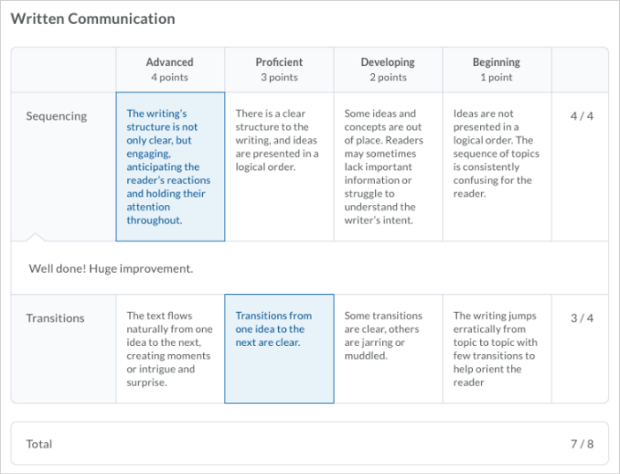
Figure: Graded rubric feedback for an assignment
Rubrics are associated directly with course activities, so you may have the option to view the criteria used to assess your activity before you submit your work. However, in some cases, your instructor may choose to hide a rubric for an activity until it is graded and feedback is published. This may be done to prevent learners from using rubrics as answer keys for activities. For example, your instructor may describe assessment expectations in assignment instructions, hiding the associated preview rubric. Once the assignment is graded, your instructor releases the graded rubric as part of your assessment details.
The graded rubric for the activity includes achieved criteria, personalized feedback, and score. In some cases, the activity includes a link to the graded rubric. For example, a discussion shows instructor feedback, score, and a link to the graded rubric.
When you are notified that your grade for an activity is released or updated, you can view the feedback from the respective tool. For example, to view assignment feedback, go to Assignments.
Note: Depending on how Brightspace Learning Environment is configured in your organization, you may also go to Grades, User Progress and Content to see completed rubric feedback for activities. In User Progress, you can only see the names of the rubrics if there are multiple rubrics attached to an activity.

View course achievements with Awards
The My Awards tool enables learners to see merit-based awards granted by instructors of a course. There are two types of awards: Badges and Certificates.
Badges are awarded based on any criteria determined by the instructor. They are meant to provide digital markers that represent accomplishment throughout a course or program. Badges do not contribute to achieving a passing grade; however, badges are awarded for achievements that also can contribute to the type of work ethic that results in a passing grade. For example, an instructor might create a badge that is based on posting 15 discussion posts in the first month of a course, or on perfect attendance, or on academic excellence. These items are the types of trends that can help a learner to succeed in a course or program.
Certificates are also awarded based on criteria determined by the instructor. Certificates are similar to Badges; however, they include a PDF that learners can print. Certificates typically indicate an official statement of certification or award at the end of a program, but can be awarded during the course for other criteria as well. Certificates can be awarded based on achieving a milestone that a learner can use for further academic or career success, such as passing a practical exam. Certificates also do not contribute to achieving a passing grade.
You can view the awards you've earned and the awards available to be earned in the My Awards tool. All awards are displayed as images and you can click on an image to view more details.

About new award notifications
When you earn a new award, you are notified in Brightspace Learning Environment, and depending on how your instructor has configured the notification, you may also get a notification email.
When you log into the course offering in which you earned the new award, a popup appears to congratulate you. You can click View Awards to open the My Awards tool and view all your awards. All awards are displayed as images and you can click on an image to view more details. If you have earned more than one award, a Next button appears on the pop-up so you can move ahead to view subsequent awards.
Subscriptions alerts on the minibar also displays a notification about new awards.

To view awards
- On the navbar, click Awards.
- To see the awards you've already earned, click My Awards.
- To filter the awards that appear, click All, Badges, or Certificates.
- To view all the awards you've earned in the courses you have participated in, select Include awards from other courses.
- To view the other awards that you have not yet earned in the course, click View Available Awards.

Share earned awards
Earning awards in a course is a great accomplishment. You can share the good Announcements with others by sharing the award to your Brightspace Learning Environment user profile, Brightspace ePortfolio or to Mozilla Backpack.
Note: An administrator must turn on the ability to share awards to Brightspace ePortfolio or Mozilla Backpack. Visit https://support.mozilla.org/en-US/products/open-badges/display-badges for more information on Mozilla Backpack.
- On the navbar, click Awards.
- Find the awards that you want to share.
- If you want to filter awards to the specific course you are currently viewing, clear the Include awards from other courses check box.
- Click the Share link on the award you want to share.
- Select the location where you want to share the award.
- Click Close.

View course progress with the Class Progress tool
The Class Progress tool helps track your progress in a course by measuring the completion of different progress indicators. You may want to use the Class Progress tool to keep track of your course-specific assignments and feedback. Instructors can use the Class Progress tool to track your overall progress in the course and prepare progress reports.
Progress reports are available for the following progress indicators: Summary, Grades, Standards, Objectives, Content, Discussions, Assignments, Quizzes, Checklist, Surveys, and Login History.
Note: Based on your organization's settings, the Standards tab may have a different label, for example, Learning Outcomes. In addition, some of the tabs may not display.
To view your course progress in the Class Progress tool
From the navbar, click Class Progress. The Summary tab displays.
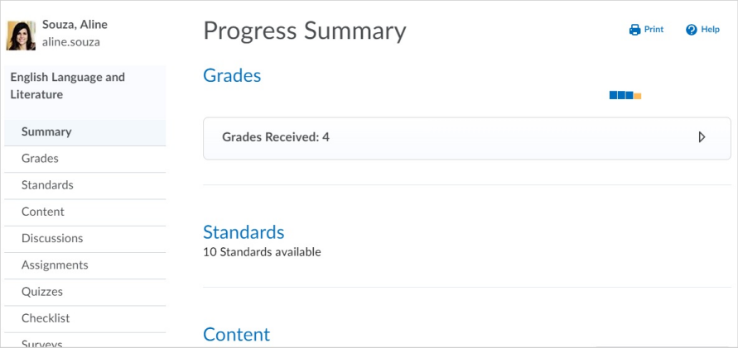
To view details of your progress within each category, click the Expand icon. For example, the Grades area displays all graded items and their feedback in the course. You may also see the distribution of grades for the rest of the class. On this graph, a black dot represents your grade. To view graded rubrics and feedback, click Feedback.
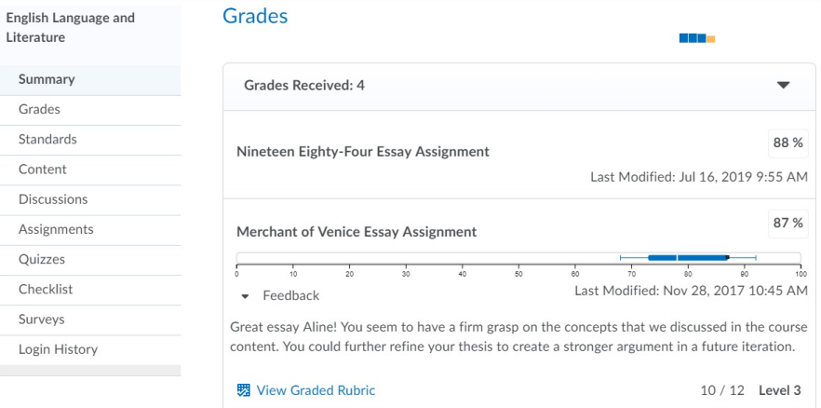
Note: This assessment information applies to other categories in Class Progress such as Discussions, Assignments and Quizzes, making all of your grades and feedback accessible from one location.
Other tabs in the Class Progress tool display more detailed information about your progress. For example, the Content tab displays your progress in content. Each module has a progress bar that displays your completion level. You can expand each module to see which topics you have and haven't completed.
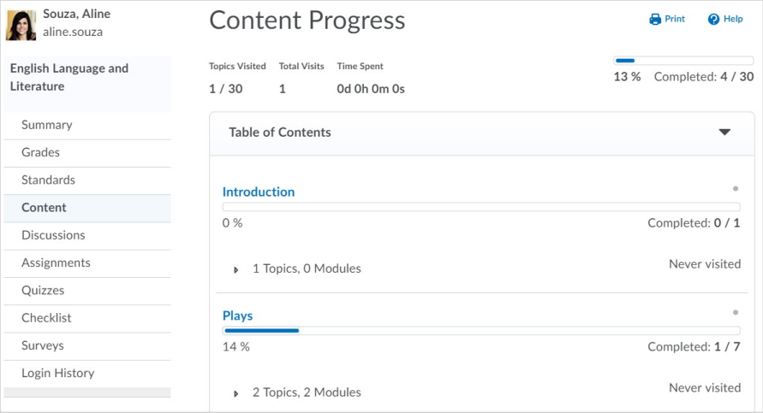

View course progress against learning outcomes
To view a learner's progress against learning outcomes in a course, the Class Progress tool includes a Standards tab. This tab displays a history of the learner's submissions and assessments against all learning outcomes aligned to activities in the course.
Note: The language term used to describe learning outcomes depends on the value set for the d2l.Languages.Terminology.LearningOutcomes configuration variable. For example, the Standards link in Course Administration might be labeled Competencies, Expectations, Objectives, or Learning Outcomes.
For instructors, this enables them to:
- View all the learning outcomes that are aligned to activities in the course, so that they can understand the learning outcomes that their learners are expected to demonstrate.
- View each learner's current assessment against each learning outcome, so that they can alter or individualize instruction, based on the learner's performance.
- View a list of all the evidence that has been assessed for a specific learning outcome, so that they can quickly familiarize themselves with feedback they provided for assessments.
For learners, this enables them to:
- View all the learning outcomes that are aligned to activities in the course, so that they can understand all the learning outcomes they are expected to demonstrate in the course.
- View their current assessment against each outcome, so that they can understand their progress against each learning outcome.
- View a list of all the feedback their instructor has provided for a specific learning outcome, so that they can understand where they might need to make more effort.
- If the organization has provided the ability for learners to view outcomes aligned with quizzes, learners can see if more than one attempt was made, and the results for each attempt.
To view progress against learning outcomes:
- As an instructor or learner, navigate to Class Progress. If you are an instructor, select a learner to view.
- Click Standards. The overview for the course lists all the learning outcomes that are aligned to activities in the course, with a mini-visualization of the last few assessments made for the learner against each learning outcome.
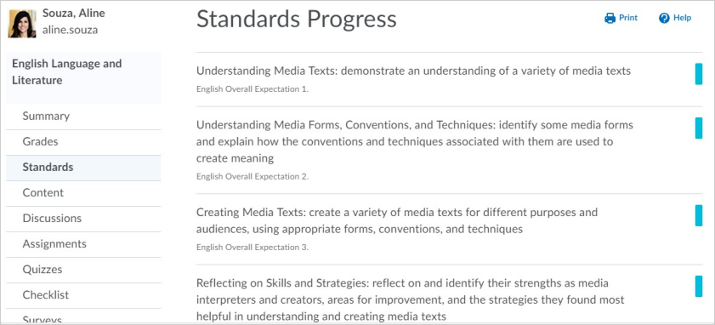
- Clicking a learning outcome provides a detailed view of an individual learning outcome. The Trend section displays a trend visualization of assessments. The Evidence section displays a list of all the activities that have been assessed so far. Clicking an activity displays the feedback and assessment area for the learner's submission of that activity.
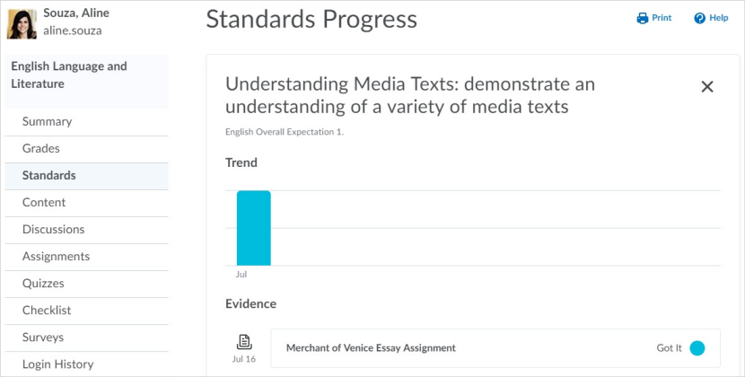

Reflect on your learning with the Self Assessments tool
Self assessments are a series of questions, similar to quizzes, that provide the opportunity to reflect on your learning and course material comprehension. Responses to self assessments are not graded; they are meant to help your instructor evaluate learner learning and their course material on an informal basis.
Note: If you need to make a change to your self assessment response or delete a self assessment, contact your course instructor.
- From the navbar, click Self Assessments.
- On the Self Assessment List page, click the self assessment you want to take.
- Answer the questions.
- Click Submit.

Create an Activity Feed post
Activity Feed is a course homepage widget that provides a central location for learners and instructors to post messages that are visible to the entire class. For example, your instructor might post reminders about upcoming assignments and links to course materials. Instructors determine if learners can post Activity Feed messages. This feature may not be available in all courses.
You can add attachments by copying and pasting a web link or embed code, or using the attachment icons. For a rich and immersive experience, most attachments can be previewed, viewed, or interacted with directly in the feed. For example, web links show a thumbnail and description, if available. Images uploaded from your computer, remote plug-in attachments, and videos embedded from YouTube, Vimeo, and TED display directly in the feed and can be viewed without leaving the course homepage.
Note: The Activity Feed only renders embedded material that administrators have set using the Trusted Sites tool. If you attempt to embed an untrusted site, the material is attached, but as a non-embedded web link.
To post messages and add attachments:
- Navigate to a course homepage with the Activity Feed widget available.
- Click anywhere in the Create a post text box.
- Enter a message
- Optionally, add an attachment by doing one of the following:
  - To attach a web link or embed code, copy and paste the link or embed code in the message.
  - Click the attach icon, and do one or more of the following:
    - To upload a file from your computer, click the file upload icon.
    - To attach a link to course materials, click the existing activity icon.
    - To attach a web link, click the weblink icon.
    - To attach a link to a Google Drive file from your Google account, click the Google Drive icon.
Note: Before attaching the link, ensure that the file has proper visibility permissions in Google Drive.
    - To attach a link to a OneDrive file from your OneDrive account, click the OneDrive icon.
Note: Before attaching the link, ensure that the file has proper visibility permissions in OneDrive.
    - To insert videos from YouTube, Vimeo, and TED, click the video icon and add a URL.
- Click Post.
Note: You may not see all the icons listed above. The attachment options are determined by the permissions and integrations available at your organization.

Find and contact other learners in your course with Classlist
Use the Classlist to view who is enrolled in your course, send email messages or instant messages, view shared locker files, and read their blogs if they have one.
To find and contact other learners in your course with Classlist
- On the navbar, click Classlist.
- On the All tab, select the check boxes beside the users you want to contact.
- Click Page or Email.
- Enter your message. To add an attachment to your email, click Browse.
- Click Send.

Share information using the Blog tool
The Blog tool is a way to share information on topics that interest you. Use this page to post and respond to questions, engage in discussions, and share opinions and comments with other users. Blog entries can be public or private.
The Blog tool has three main areas:
- My Blog for creating and maintaining your own blog.
- Blog Watch for reading other users' blogs.
- Blog List for setting up which other users' blogs you want to watch.
From the My Blog page or the Blog Watch page, you can change the following settings for your blog on the Settings page.
Setting | Description
Show a link to your user profile from your blog | Allow users who are viewing your blog to also view your profile
Make entries public by default | Selects the Make Public option for new blog entries so they are automatically shared with other users by default.
Allow comments by default | Selects the Allow comments option for new blog entries by default. Note that this option is only available if the Make entries public by default option is selected.
Receive email when comments are added | Select this option to receive an email notification when a new comment is made on one of your blog entries.
Allow blog to be read by anyone | Allow users who are not logged into Brightspace Learning Environment to view your blog through an external URL. The External URL field contains the URL to share your blog. Note that you cannot access private blog entries by URL.
Publish your blog as an RSS feed | Allow readers of your blog to link to your Site Feed and view your blog using an external RSS aggregator. To publish your blog in this way, you must enter a title for it in the Feed Title field.
Persistence | Enter a value in the Persistencefield to determine how long blog entries stay in your Blog Watch list. For example, if you enter 10, entries will remain in your Blog Watch for 10 days after being posted. If you set the value to 0, blog entries remain in your Blog Watch indefinitely.

View your own blog
- On the My Blog page, use the All Entries, Public Entries, and Private Entries tabs to view your blog entries.
- To view how your blog appears to others, click Preview Blog.
Tip: The Permalink field at the top of the Preview page lists a URL for your blog that can be accessed from any browser.

Write a blog entry
- On the My Blog page, click New Entry.
- Enter a title. The title appears in the blog entry list after you publish it.
- Add content to your blog.
- If you want to allow other users to view your blog entry, select Make entry public.
- If you want to allow other users to comment on your blog entry, select Allow Comments.
- If you want the blog entry to show a different date from the current date and time, change the Entry Date. To revert to the default values, click Now. The Blog displays the most recent entries first, according to the entry date you set.
- Click Save.
After you create your blog entry, click Preview to view your blog as it appears to others and to view the permalink and social media links to share your blog outside of your course.

Edit blog entries
- On the My Blog page, from the context menu beside the title of the entry you want to edit, click Edit.
- Update the entry as desired.
- Click Save.

Find and follow other users' blogs
The Blog Watch keeps a list of blogs by your peers and other users that you want to follow. To populate your Blog Watch, you add blogs from the Blog List. Your Blog Watch is empty by default.
- Click Blog List.
- Do one of the following:
  - Search for a user's blog by entering any portion of their first or last name in the Search For field.
  - Navigate the list of users. You can sort the table by clicking any of the column names. If you go to a new page, you lose the users that you selected on the previous page.
- Select the check box beside any user that you want to watch.
- Click Add.
To see recent posts from the blogs that you follow, click Blog Watch.

Publish your blog as an RSS feed
You can publish your blog as an RSS feed which any external news reader (RSS aggregator) can read. Depending on your organization, you might not have permission to use the RSS feed functionality.
- Click Settings, then select Publish your blog as an RSS feed.
- Enter a title and a description.
- Click Save.
- Share the External URL with other users to share your blog.

Add blog comments
- In the blog entry you want to comment on, click the Add Comment link. The writer must enable comments on their blog in order for you to see the Add Comment link.
- In the Comment field, enter your comment. Select Make this comment anonymous to submit an anonymous comment.
- Click Save Comment.

Delete blog comments
You can remove comments on your own blog. You cannot delete comments on another user's blog.
- On the My Blog page, click Edit from the context menu of the blog entry or click the Comments link inside the entry.
- Click the Delete icon beside the comment.

Create a personal chat with the Chat tool
The Chat tool is a real-time, text-based collaboration tool. You can use the Chat tool to brainstorm ideas, hold a question and answer period, have a debate or discussion, or organize a remote study group. As opposed to other collaboration tools, such as Discussions, Chat conversations occur in real-time.
You can create personal chats to talk with peers or other friends at your organization. You can create personal chats from any org unit, and you can access them within any other org unit.
Personal chat rooms can only be accessed by users who have been added to the personal chat’s Participant List. When users are added, the chat room displays under Personal Chats in their list of chats.
To create a personal chat with the Chat tool
- On the navbar, click Chat.
- On the Chat List page, click New Chat.
- Enter a title.
- Click Personal Chat.
- Enter a description of the chat. Give your chat a unique, descriptive name and provide a description for it using the Description field to help users distinguish the chat from other chats they are enrolled in.
- Click Create.

Change your chat settings
- On the navbar, click Chat.
- Do one of the following:
  - On the Chat List page, click Settings.
  - Inside a chat, click Settings.
- In the Alias field, enter a new alias. Depending on your permissions, you can change your alias, or chat name, if you want to appear as a different name, such as a nickname, to other chat participants.
- Select the check boxes for Bold or Italics.
- Set an Alias Color.
- If you want to change the message order, select New to Old or Old to New. If you want to see new messages only, select New Messages. This requires you to manually refresh the screen, to see new messages and remove all old ones. You can change back to see all messages, which restores all messages for that session, even if they were not visible while New Messages was selected.
- You can change your sound settings so you can hear a sound when someone enters the chat, leaves the chat, or when there is an incoming message. Select a sound from the following drop-down lists:
  - Incoming Message Sound
  - Person Enters Chat Sound
  - Person Leaves Chat Sound
- Click Save.
Note: If you use a preferred name and do not have permission to manage your own Chat Alias, your preferred name is still reflected in the Chat tool.

Manage chat history
The chat’s archive stores each chat session, where you can view it at a later time.
The system archives a chat session once all chat members leave the room. Chats appear in the Chat Sessions list.
- On the navbar, click Chat.
- On the Chat List page, from the context menu beside the chat you want to view, click View Sessions.
- In the Start Date column, click the link.
- When you are done reviewing the session, click Done.

Add or remove users from a chat
- On the navbar, click Chat.
- On the Chat List page, from the context menu of the personal chat you want to modify, click View Members.
- Do one of the following:
  - To add a member to the chat, click Add Members. To add users from different course offerings click Select Different Course. Select the check box beside the name of users you want to add. Click Add > Done.
  - To add a personal contact, click Add Personal Contact. Select the check box beside the name of users you want to add. Click Add > Done.
  - To delete a member of the chat, on the Chat Members page, select the check box beside the users you want to remove. Click Delete > Done.

Create a discussion thread
The Discussions tool is a collaboration area to post, read and reply to threads on different topics, share thoughts about course materials, ask questions, share files, or work with your peers on assignments and homework.
Important: When copying and pasting formatted content from other sources, the HTML Editor in the Discussions tool contains some limitations. For example, if you copy content from a document with APA formatting and paste it into a discussion thread, the formatting is not preserved. As a best practice for submitting assignments, D2L recommends using the Assignments tool. If you choose to use the Discussions tool, D2L recommends submitting documents as attachments in the tool, which preserves document formatting.
To create a discussion thread
- On the navbar, click Discussions.
- Click the topic where you want to create a thread.
- Click Start a New Thread.
- Enter a subject.
- Enter your post.
- Set any of the following posting options:
  - To keep the thread at the top of the list, select Pin Thread.
  - To post anonymously, select Post as Anonymous.
  - To receive updates on the thread using your selected notification method, select Subscribe to this thread.
  - To attach a file, in the Attachments area, click Browse to locate the file that you want to attach.
  - To attach an audio recording, in the Attachments area, click Record Audio > Record. To make adjustments to your microphone selection and volume, click Flash Settings. To listen to your recording, click Play. To erase your recording, click Clear. If you have prerecorded audio and are using a supported browser, you can drag audio files onto the attachments upload target.
  - To attach a video recording, in the Attachments area, click Record Video > Allow > Record. When you finish recording, click Stop. To erase your recording, click Clear. To add the recording, click Add. If you have pre-recorded video and are using a supported browser, you can drag video files onto the attachments upload target.
  - To post your thread to more than one topic, click Post to other topics. Click Add Topics. Select the topics that you want your thread to appear in. To post in every topic simultaneously, select the Select All check box and then click Add Topics.
- Click Post. If the topic is moderated, your post does not appear until a moderator approves it.

View a discussion topic
If you are viewing a topic from the Discussions tool:
- On the navbar, click Discussions.
- On the Discussions List page, click on the name of the discussion topic. The properties of the discussion topic related to availability, locking information, and any other details set by an instructor, are listed directly below the name of the discussion topic.
- From the Filter by drop-down list, select an option, by which you can sort the individual discussion posts.
If you are viewing a topic from the Content tool:
- On the navbar, click Content.
- Click on a module.
- Click on the name of a discussion topic.
Note: You cannot view the properties of the discussion topic when you view the topic using the Content tool.
- From the Filter by drop-down list, select an option, by which you can sort the individual discussion posts.

Reply to a discussion thread
- On the navbar, click Discussions.
- Locate the thread you want to reply to.
- Do either of the following:
  - To reply to the main thread post, click Reply to Thread.
  - To reply to a particular post inside the thread, or click Reply.
- Enter your reply in the HTML Editor. To include the original post’s text in your reply, click the Add original post text link. (If this option is already enabled by your course administrator, this message will not display.)
- Set any of the following options:
  - To post anonymously, select Post as Anonymous.
  - To receive updates on the thread using your selected notification method, select Subscribe to this thread.
  - To attach a file, in the Attachments area, click Browse to locate the file you want to attach.
  - To attach an audio recording, in the Attachments area, click Record Audio > Record. To make adjustments to your microphone selection and volume, click Flash Settings. To listen to your recording, click Play. To erase your recording, click Clear. If you have pre-recorded audio and are using a supported browser, you can drag audio files onto the attachments upload target.
  - To attach a video recording, in the Attachments area, click Record Video > Allow > Record. When you finish recording, click Stop. Click Clear to erase your recording or Add to add the recording. If you have pre-recorded video and are using a supported browser, you can drag video files onto the attachments upload target.
- Click Post.

Change discussion settings
- On the navbar, click Discussions.
- On the Discussions List page, click Settings.
- Do any of the following:
  - To show topics in the View Topic and View Thread pages, select the Always show the Discussions List pane check box.
  - To hide topics in the View Topic and View Thread pages, clear the Always show the Discussions List pane check box.
  - To automatically include the original post when replying, select the Reply Settings check box.
- Click Save.

Subscribe to a discussion
- On the navbar, click Discussions.
- Do either of the following:
  - On the Discussions List page, from the context menu of the forum or topic you want to receive notifications of new posts for, click Subscribe.
  - On the View Topics page, beside the thread you want to receive notifications for, click Subscribe.
- In the Customize Notifications pop-up window, select your Notification Method. If you do not have an email address set up in your user profile to receive notifications, in the Customize Notifications pop-up window, click the Add an email address in a new window link. Click the Enable email notifications link, then set your email preferences in the Email Settings pop-up window. Click Save.
- Click Subscribe.

Unsubscribe from a discussion
- On the navbar, click Discussions.
- Do either of the following:
  - From the context menu of the forum or topic you are subscribed to, click Unsubscribe.
  - Beside a thread you are subscribed to, click Subscribed.
- In the confirmation pop-up window, click Yes.

Email other learners with the Email tool
The Email tool allows you to send email from within Brightspace Learning Environment. You can also organize received mail using folders and store email addresses using the Address Book.
From the navbar, click Email.

Where can I find my Instructor's email?
Some good places to find your instructor’s email address are:
- Your Course Syllabus. This may be posted in the Content tool in Brightspace Learning Environment
- Your class list
- The Classlist tool in Brightspace Learning Environment

I am unable to login to my school email portal (not Brightspace), what do I do?
If you are unable to log in to your school email portal, contact your institution’s Help Desk.

Why can I only see some emails in my inbox?
If you know you have more emails than you can see on the page:
- Ensure the email filter is not restricting the emails you are seeing. From the Filter By list, select All Messages.
- You might have multiple pages for your email. Make sure to look through all pages and/or expand the number of emails that appear per page.

How can I forward my D2L emails to another account?
To forward D2L emails to another account:
- From the navbar, click Email.
- Click Settings.
- Under Forwarding Options, check the Forward incoming messages to an alternate email account check box. Enter the forwarding Email Address, then select your preferences.

I get a "Not Authorized" error trying to access my Email, what do I do?
From the navbar, click on your Message Alerts (envelope icon). Do you see this message?
You must complete the following quizzes for alerts to be enabled: {Quiz Name}
Once you complete the quiz detailed in the message alert, you will be able to access your email - while the quiz is in progress, your email access is disabled by your instructor.

I cannot access my email inbox, I can only send emails
Your institution has send-only email enabled. You cannot receive emails in Brightspace.

Upload, store, and share files with the Locker tool
Use the Locker tool to upload and store files in Brightspace Learning Environment. Locker enables you to upload files from your PC, or to create new HTML files.
Your personal locker area is not course-specific. You can access the locker from anywhere in Brightspace Learning Environment and store all of your files together.
Group lockers are restricted locker areas where members of a group can share files. Any group member can modify files posted in group locker areas.
Group lockers have the same options as regular lockers with the following exceptions:
- The option to make locker files public is not available.
- There is an option to Email Group Members.
- There is a Modified By column that shows the last person to work on a file.
From the navbar, click Locker.

Find other learner's shared locker files
- On the navbar of a course, click Classlist.
- From the context menu of the user whose shared locker files you want to view, click View shared locker files.
- Click the file name you want to open, or specify a file type in the Files of Type drop-down list.

Submit course feedback with the Surveys tool
Surveys are an excellent way to solicit feedback from participants regarding any aspect of a course. For example, use surveys as a method of collecting course evaluations, mid-year reviews, or researching people's learning styles and content delivery preferences.
- Navigate to a course.
- From the navbar, click Surveys.

Anonymous participation in a survey
If a survey is anonymous, your user data is hidden in survey results. The responses to survey questions are available for all users, but the system does not report who made which response.
Note: You cannot associate anonymous survey activities with learning objectives.

Why can't I create a survey?
The Surveys tool is designed to be an assessment tool in courses and provide a way for instructors to solicit feedback from participants regarding any aspect of a course.

About D2L
A global leader in EdTech, D2L is the creator of Brightspace, the world’s first integrated learning platform.
The company partners with thought-leading organizations to improve learning through data-driven technology that helps deliver a personalized experience to every learner, regardless of geography or ability. D2L’s open and extensible platform is used by more than 1,100 clients and almost 15 million individual learners in higher education, K–12, healthcare, government, and the enterprise sector—including Fortune 1000 companies.
The company has operations in the United States, Canada, Europe, Australia, Brazil, and Singapore. www.D2L.com

Contact Us
Phone: | 1.519.772.0325 (Worldwide)
Toll Free: | 1.888.772.0325 (North America)  0.808.234.4235 (United Kingdom and Europe)  0.800.452.069 (New Zealand)  1.800.656.210 (Australia)  0.800.891.4507 (Brazil)
Fax: | 1.519.772.0324
Email: | info@brightspace.com
Twitter: | @Brightspace
Web: | www.D2L.com

© 2020 D2L Corporation.
The D2L family of companies includes D2L Corporation, D2L Ltd, D2L Australia Pty Ltd, D2L Europe Ltd, D2L Asia Pte Ltd, and D2L Brasil Soluções de Tecnologia para Educação Ltda.
Brightspace, D2L, and other marks ("D2L marks") are trademarks of D2L Corporation, registered in the U.S. and other countries. Please visit d2l.com/trademarks for a list of other D2L marks.

